What will we be learning?  - Biomechanics | Why this? Why now?  This unit is a compulsory for the A level course which will be examined through the H555/01 paper at the end of year 13. | Key Words:  Balanced  Net force  Momentum  Inertia  Velocity  Action  Reaction  Friction  Weight  Streamlining  Fulcrum  Effort  Load  Mechanical advantage  Axis of rotation  Drag  Parabolic  Non-parabolic  Lift force  Magnus effect  Hook  Slice  Top spin  Back spin
What will we learn? Year 1
3.1 Biomechanical principles:
- Newtons laws of motion
- Calculating linear motion and net force
- The use of technology
3.2 Stability and lever systems
Year 2
9.1 Linear motion
9.2 Angular motion
9.3 Fluid mechanics and projectile motion
What opportunities are there for wider study?
Optional Booster sessions
Careers/degree courses
- Sports science
- Physiotherapy
- PE teacher
- Sports analysis
- Biomechanistic
How will I be assessed?
- Everlearner set assignments/check points
- Topic tests
- End of unit tests
- Mock Exams
A level - Biomechanics

What will we learn?  3.1 Biomechanical principles  - Newtons 3 laws of motion & Links to sporting examples  - Calculations: Momentum, Velocity, acceleration, Force  - Force and its effects  - Net force  - Vertical forces  - Horizontal forces  - Freebody diagrams  - Limb Kinematics  - Force plates  - Wind tunnels | 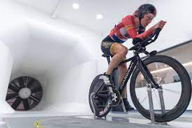  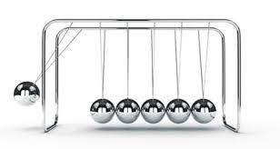
- Stability and lever systems  - Factors affecting stability  - Lever systems  - Mechanical advantage of second-class lever system | 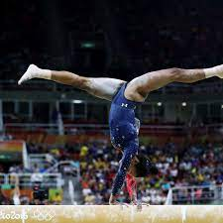
- Linear motion  - Measurements and calculations for Distance, Displacement, Speed, Velocity  - Measuring Acceleration/deceleration  - Interpreting graphs of linear motion and velocity time graphs | 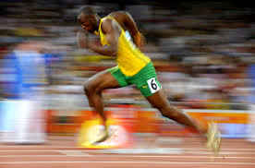
  - Angular motion
- Torque
- Axis of rotation
- Angular Velocity
- Moment of inertia
- Angular momentum
- Conservation of Angular momentum
- Fluid mechanics and projectile motion  - How Drag and air resistance can impact performance  - Projectile release  - Projectile in flight  - Free body diagrams of projectiles in motion  - Bernoulli principle  - Spin and Magnus Force | 